Activity 2

Question 1

Use Greatest films to Create a calculated column in a calendar table dividing the year into thirds.

Question 2

|  |  |
| --- | --- |
| Software: | [PowerPivot](https://www.wiseowl.co.uk/power-bi/exercises/powerpivot/) |
| Version: | Excel 2016 and later |
| Topic: | [The CALCULATE function](https://www.wiseowl.co.uk/power-bi/exercises/powerpivot/the-calculate-function/) |
| Level: | Relatively easy |
| Course: | [PowerPivot / Excel Power BI](https://www.wiseowl.co.uk/courses/excel-data-analysis.htm) |
| Exercise: | Use the CALCULATE function to show percentages of row and column totals in a pivot table. |
| Data |  |

Before you can do this exercise, you'll need to download and unzip qf-298(2).zip

1. Go into SQL Server Management Studio;
2. Open the SQL file you've just unzipped (you can press CTRL + O to do this); then
3. Execute this script.

This will generate the database that you'll need to use in order to do this exercise (note that the database and script are only to be used for exercises published on this website, and may not be reused or distributed in any form without the prior written permission of Wise Owl).

Create a new workbook, and import the following tables into a new PowerPivot data model:

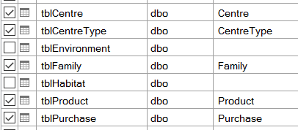

As ever, give your tables friendly names too.

Create a pivot table based on this model, showing total quantity sold by family and centre type:

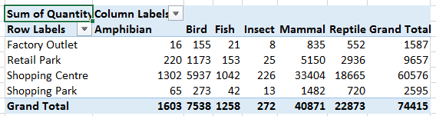

A vanilla pivot table!

Create a measure to show in each cell total sales for that centre type and that family, divided by total sales for that centre type for all families.  The numerator can just show total sales:

**=SUM ( [Quantity] )**

The denominator will be more complicated:

**=SUM( [Quantity] ) / CALCULATE ( SUM ( [Quantity] ), ALL ( ... ) )**

The resulting pivot table should look like this:

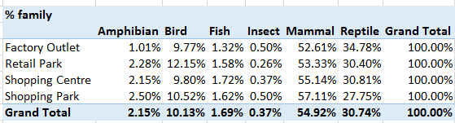

You can actually do this in normal Excel pivot tables too, although PowerPivot will let you create much more complicated measures than this.

Feeling flushed with success?  Try creating and showing another measure, this time to show sales as a percentage of all centre types:

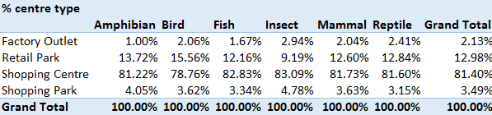

**Question 3**

|  |  |
| --- | --- |
| Software: | [PowerPivot](https://www.wiseowl.co.uk/power-bi/exercises/powerpivot/) |
| Version: | Excel 2016 and later |
| Topic: | [The CALCULATE function](https://www.wiseowl.co.uk/power-bi/exercises/powerpivot/the-calculate-function/) |
| Level: | Average difficulty |
| Course: | [PowerPivot / Excel Power BI](https://www.wiseowl.co.uk/courses/excel-data-analysis.htm) |
| Exercise: | Create a ratio of sales between two different habitats, using the CALCULATE and SUMX functions. |

**PowerPivot | The CALCULATE function exercise | Use CALCULATE to show the value of sales for watery habitats**

Before you can do this exercise, you'll need to download and unzip this file (if you have any problems doing this, click here for help). Once you've done this:

Go into SQL Server Management Studio;

Open the SQL file you've just unzipped (you can press CTRL + O to do this); then

Execute this script.

This will generate the database that you'll need to use in order to do this exercise (note that the database and script are only to be used for exercises published on this website, and may not be reused or distributed in any form without the prior written permission of Wise Owl).

The aim of this exercise is to show the percentage of the values of sales for each region attributable to watery habitats.  Read on!

First import the following tables into a PowerPivot data model in a new workbook:

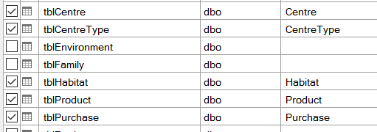

The tables that you'll need to import for this exercise.

In the **Purchase** table, create a measure to calculate the total value of sales for habitats with id numbers 3 and 4 (corresponding to fresh and salt water respectively).

You'll need to use the **CALCULATE** function, the **SUMX** function to sum (price * quantity) and the double pipe characters ( || ) to denote "or".

Use this measure to show total watery sales by shopping centre type:

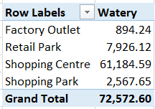

You should format your numbers to look nice!

Now create another (similar) measure called **Vegetation**, showing the total value of sales for vegetative habitats (id numbers 1 and 2, for grasslands and forest respectively).

Use this to create and show a third measure called **Water-to-veg ratio**, to get this pivot table:

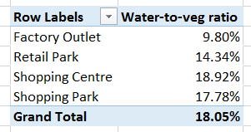

Factory outlets have the smallest ratio (surely a fact worth shouting about).

Save your workbook as **What about the desert**, then close it down.

Question 4

|  |  |
| --- | --- |
| Software: | [PowerPivot](https://www.wiseowl.co.uk/power-bi/exercises/powerpivot/) |
| Version: | Excel 2013 and later |
| Topic: | [The CALCULATE function](https://www.wiseowl.co.uk/power-bi/exercises/powerpivot/the-calculate-function/) |
| Level: | Relatively easy |
| Course: | [PowerPivot / Excel Power BI](https://www.wiseowl.co.uk/courses/excel-data-analysis.htm) |
| Exercise: | Use the CALCULATE function to pick out only transactions whose price is a given amount. |

**PowerPivot | The CALCULATE function exercise | Use CALCULATE to divide transactions into expensive and cheap**

Before you can do this exercise, you'll need to download and unzip this file **qf-255.zip**

If you haven't already done so, run the SQL script in the above folder (copying and commercial use prohibited) to generate a database called **MAM**.

Create a new workbook, and in this a data model similar to this one:

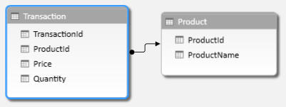

As long as you have these two tables, the details aren't important.

Create a pivot table showing total quantity sold per product:

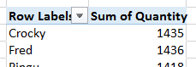

So far, so easy!

Now create and display two calculated fields, using the **CALCULATE** function:

1. One which shows the total quantity sold for goods where the price is £10 or more (call this **Expensive**); and
2. One which shows the total quantity sold for goods where the price is less than £10 (call this one **Cheap**).

The final pivot table should look like this:

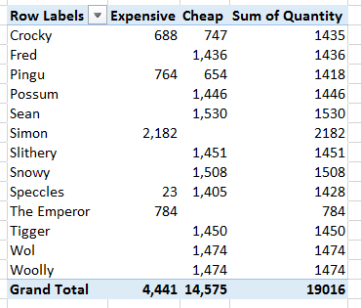

For each product, it would be worrying if the cheap and expensive columns didn't sum to the total!

Save this workbook as **Partitioning the set**, and close it down.

Question 5

|  |  |
| --- | --- |
| Software: | [PowerPivot](https://www.wiseowl.co.uk/power-bi/exercises/powerpivot/) |
| Version: | Excel 2013 and later |
| Topic: | [The CALCULATE function](https://www.wiseowl.co.uk/power-bi/exercises/powerpivot/the-calculate-function/) |
| Level: | Average difficulty |
| Course: | [PowerPivot / Excel Power BI](https://www.wiseowl.co.uk/courses/excel-data-analysis.htm) |
| Exercise: | Use CALCULATE to work out the ratio of total sales to sales for a specific type of animal. |

f you haven't already done so, run the SQL script in the above folder (copying and commercial use prohibited) to generate a database called **MAM**.

Create a data model similar to the one below (it doesn't matter what fields you hide from client tools, as long as you include these tables):

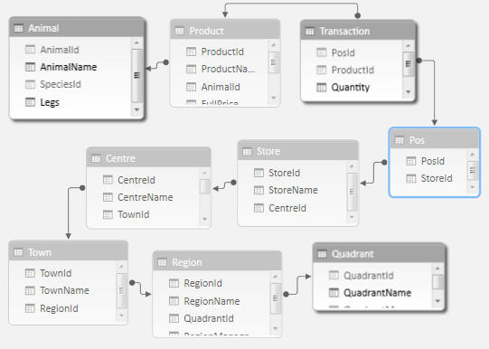

The tables to include, allowing us to link quadrants to animals.

Now create this pivot table showing the number of legs for each animal across the top, and the quadrant name down the left-hand side:

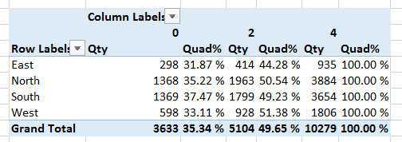

See below for notes.

This pivot tables shows:

* The total quantity sold for each cell's query context; and
* The percentage this constitutes of the total for quadrupeds.

Use the **CALCULATE** function for the denominator for the ratio.

If you've got this working, add another calculated field which shows the percentage of the total for all leg types, using **CALCULATE** and **ALL**:

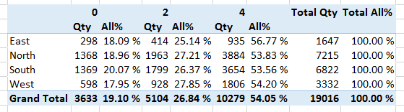

Reassuringly, the total on the right is 100%. Quadrupeds constitute just over 54% of total sales.

When you've finished, save this query as **Four legs good**, and close it down.

**Question 6**

|  |  |
| --- | --- |
| Software: | [PowerPivot](https://www.wiseowl.co.uk/power-bi/exercises/powerpivot/) |
| Version: | Excel 2010 and later |
| Topic: | [The CALCULATE function](https://www.wiseowl.co.uk/power-bi/exercises/powerpivot/the-calculate-function/) |
| Level: | Relatively easy |
| Course: | [PowerPivot / Excel Power BI](https://www.wiseowl.co.uk/courses/excel-data-analysis.htm) |
| Exercise: | Divide sales by 4 legs and other for a measure, using the FILTER function. |

**PowerPivot | The CALCULATE function exercise | Use FILTER to show total quantity for quadrupeds separately**

Before you can do this exercise, you'll need to download and unzip [this file](https://www.wiseowl.co.uk/files/execise-question-files/qf-178.zip) To start, if you haven't already done so run the script in the above folder to generate the **MAM** database (not for commercial use or copying).

Create the following data model:

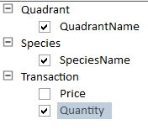

You'll need to import (deep breath) the **Animal**, **Centre**, **Pos**, **Product**, **Quadrant**, **Region**, **Species**, **Store**, **Town** and **Transaction** tables.

Use this to create the following basic pivot table:

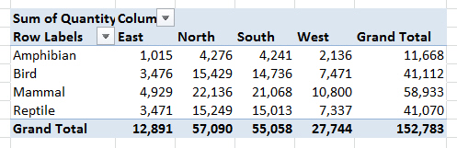

This pivot tables shows total quantities sold by quadrant and species.

Add a measure which (you think) should give the total quantity sold for four-legged animals only:

**=SUMX(FILTER(Animal,Animal[Legs]=4),'Transaction'[Quantity])**

You should find this gives an error:

Error message

The start of the error message.

The problem is that you can't filter by one dimension but sum a column in another.  To get round this, use the **RELATED** function to include the number of legs each animal has within the transactions table:

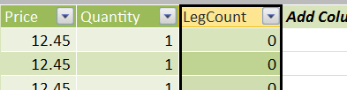

This is what your new column should look like.

Amend your measure and add another one to report on total quantity sold by quadruped and non-quadruped:

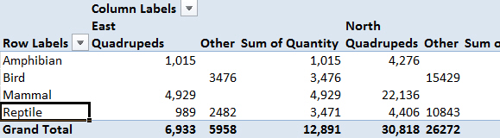

The figures to watch are those for reptiles, since this species includes snakes (0 legs) and crocodiles (4 legs).

When you've got this working, save the workbook as **Four legs good** (you may well need it again soon!), and close it down.